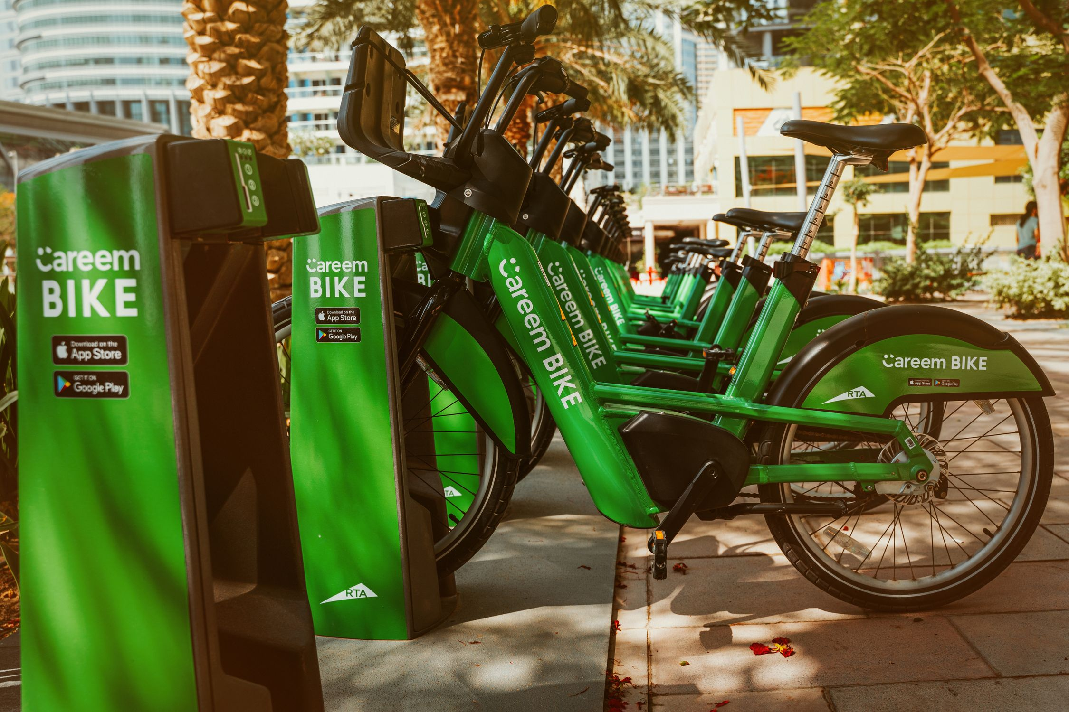

Cyclistic Bike-Share Case Study

Business Intelligence Report

July 2026
7 julio

Cyclistic Bike-Share
Creado por: León González Iván


Table Content
1. Executive Summary 3
2. Introducción 4
3. Business Problem 4
4. Project Objectives 5
4.1 Overall objective 5
4.2 Specific objectives 5
5. Dataset 5
5.1 Dataset. 5
5.2 Time Period Analyze. 5
5.3 Number of Records. 5
5.4 Principal Variables. 5
6. Metodology 6
6.1 Data Collection 6
6.2 Data Cleaning 6
6.3 Exploratory Data Analysis 6
6.4 Dashboard Development 6
6.5 Business Insights 6
7. Data Cleaning 6
7.1 Remove of Duplicates 7
7.2 Remove of Null Trips 7
7.3 Calculated Variables 7
7.4 SQL Used 7
8. Dashboard 8
9. Key Insights 9
9.1 1st insight 9
9.2 2nd insight 9
9.3 3rd insight 9
9.4 4th insight 9
9.5 5th insight 10
9.6 6th insight 10
9.7 7th insight 10
9.8 8th insight 10
10. Conclution 11

Executive Summary
Cyclistic aims to increase the number of annual members, as this customer segment generates more stable and predictable revenue than casual riders. To support this business objective, an analysis was conducted using ride data collected between May 2025 and June 2026.

The analysis identified several behavioral patterns that clearly differentiate annual members from casual users. By understanding these differences, actionable recommendations were developed to help the marketing team design strategies focused on converting casual riders into annual members.

The findings indicate that annual members primarily use Cyclistic bicycles for daily commuting and routine transportation, while casual riders are more likely to use the service for recreational and leisure activities. Although both user groups share similar periods of activity throughout the day and across the year, their riding habits differ significantly in terms of trip purpose, average ride duration, and station usage.

Based on these insights, a set of data-driven recommendations was developed to support Cyclistic's marketing strategy. These recommendations focus on targeting casual riders during their highest activity periods and promoting the benefits of annual memberships through personalized campaigns, with the goal of increasing membership conversion and strengthening long-term customer retention.

Introducción

In 2016, Cyclistic launched a successful bike-share offering. Since then, the program has grown to a fleet of 5,824 bicycles that are geotracked and locked into a network of 692 stations across Chicago. The bikes can be unlocked from one station and returned to any other station in the system anytime.

Until now, Cyclistic’s marketing strategy relied on building general awareness and appealing to broad consumer segments. One approach that helped make these things possible was the flexibility of its pricing plans: single-ride passes, fu l-day passes, and annual memberships. Customers who purchase single-ride or full-day passes are referred to as casual riders. Customers who purchase annual memberships are Cyclistic members.

Cyclistic’s finance analysts have concluded that annual members are much more profitable than casual riders. Although the pricing flexibility helps Cyclistic attract more customers. Maximizing the number of annual members will be key to future growth. Rather than creating a marketing campaign that targets al-new customers.
Three questions will guide the future marketing program:

- How do annual members and casual riders use Cyclistic bikes differently?
- Why would casual riders buy Cyclistic annual memberships?
- How can Cyclistic use digital media to influence casual riders to become members?

Our team was assigned the first question to answer:

- How do annual members and casual riders use Cyclistic bikes differently?

Business Problem

- Cyclistic seeks to increase the number of annual members, as they generate more stable revenue than casual users.

Project Objectives

4.1 Overall objective
Analyze the behavior of Member and Casual users to identify opportunities to help increase memberships.

4.2 Specific objectives
- Analyze usage patterns.
- Compare duration and distance.
- Analyze seasonality.
- Generate recommendations.

Dataset

Dataset.
The data use for this porpoise analysis was taken from the cyclistic bike-share company dataset.

Time Period Analyze.
The records related from May 2025 till June 2026 were used for this analysis.

Number of Records.
The original dataset was formed by 5,848,703 records. Once the data cleaning was performed the records were reduced to 5,846,860.

Principal Variables.
- ride_id
- member_casual
- rideable_type
- started_at
- ended_at
- start_station_name
- end_station_name
- latitude / longitude

Metodology

Data Collection
Historical trip data provided by Cyclistic was obtained from Google BigQuery. The dataset contains ride information collected between May 2025 and June 2026, including ride timestamps, user type, bike type, station information, and geographic coordinates.

Data Cleaning
- Duplicate Removal.
- Removed rides with zero or negative duration.
- Checked missing values.
- Standardized date and time fields.
- Calculated additional variables required for the analysis.

Exploratory Data Analysis
The next variables were analyzed for the report objective:
- ride duration
- trip distance
- member vs casual
- monthly trends
- daily trends
- hourly trends
- stations
- bike type

Dashboard Development
Interactive visualizations were created in Power BI to summarize the main performance indicators and compare the behavior of annual members and casual riders.

Business Insights
The dashboard enabled the identification of behavioral differences between both user groups, providing valuable insights for business decision-making.

Data Cleaning

Remove of Duplicates
- A search was conducted for repeated ride ids.
- Duplicates were removed.

Remove of Null Trips
Trips with the following were removed:

- duration ≤ 0
- inconsistent records

Calculated Variables
New variables were created to simplify the analysis, including:

- Start Date
- Start Time
- Month
- Month Name
- Day of Week
- Hour
- Trip Duration (minutes)
- Trip Distance (km)
- Member Order
- Day Order

SQL Used
SQL queries were developed in Google BigQuery to clean, transform, and enrich the dataset before importing it into Power BI.

- Apendix: BigQuery – Cyclistic Project – Consola de Google Cloud

Dashboard

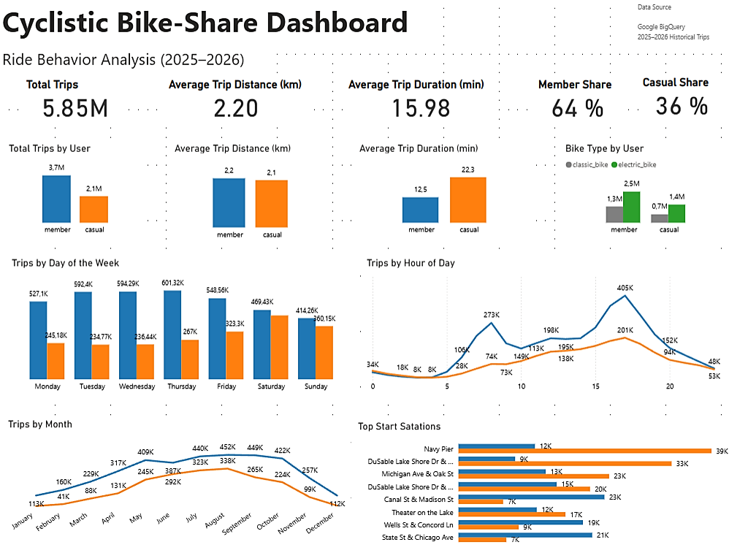
Figure 1 Cyclistic Interactive Dashboard developed in Power BI.

The dashboard begins with a set of key performance indicators (KPIs) that provide an overall view of user activity, including total trips, average trip distance, average trip duration, and the distribution of annual members and casual riders.

The second section presents comparative visualizations that highlight the differences between member and casual users in terms of total trips, average trip distance (km), average trip duration (minutes), and preferred bike type.

The third section focuses on user activity patterns throughout the week and across different hours of the day, allowing the identification of peak usage periods for each user segment.

Finally, the last section analyzes seasonal trends by illustrating monthly ridership patterns and the most frequently used start stations for both member and casual users. These visualizations provide valuable insights into travel behavior and support the development of targeted business recommendations.

Key Insights

1st insight
Members accounted for about 64% of all recorded trips, while casual users made up 36%. This shows that members use the service more often and are the main driver of Cyclistic's demand. However, the high number of trips taken by casual users shows that there's a significant segment of customers who could become members with the right marketing strategies.

2nd insight
Casual users have an average trip duration of 22.26 minutes, while members average 12.47 minutes. This difference suggests that both groups use the service for different purposes. Members are likely taking shorter trips as part of their daily mobility, while casual users tend to use the bikes for recreational or leisure activities, which explains the longer duration of their rides. This behavior presents an opportunity for Cyclistic to design campaigns targeting frequent casual users, highlighting the cost benefits and convenience of an annual membership for those who use the service for longer periods.

3rd insight
Even though members travel a greater distance between the origin and destination, their trips have a shorter average duration. This suggests that both groups use the service differently. Members might be taking more direct and efficient routes, while casual users might spend more time on the bike for recreational reasons, making stops or taking indirect routes.

Methodological note: Distance was estimated using BigQuery's ST_DISTANCE() function, which calculates the geographic distance between the start and end points of the trip. Since the complete route is not available, this metric does not represent the total distance traveled by the user and should be interpreted as an approximation.

4th insight
Regarding the type of bike used, both groups show very similar behavior, clearly showing a preference for electric bikes. The observed preference could be related to the comfort or ease of use that electric bikes offer; however, the available data does not allow us to determine the specific reasons for this choice.

Cyclistic could consider highlighting the availability of electric bikes in their marketing campaigns aimed at casual users, as long as future analyses confirm that this type of bike positively influences the decision to purchase an annual membership.

5th insight
Since casual users concentrate a larger part of their activity on weekends, Cyclistic could run digital campaigns specifically on those days, highlighting the economic benefits and convenience of an annual membership for users who use the service regularly in their recreational activities.

6th insight
The data shows that both groups concentrate most of their trips during the late afternoon hours, especially between 4:00 PM and 6:00 PM. However, when combining this result with the analysis of the days of use, an important difference in usage context is observed: members take most of their trips during weekdays, while casual users focus their activity mainly on weekends. This behavior supports the hypothesis that members use the service as part of their everyday mobility, while casual users use it more often for recreational or leisure activities.

Cyclistic could schedule digital campaigns and personalized promotions during the busiest hours, especially between 4 PM and 6 PM on weekends, taking advantage of the fact that a large portion of trips by casual users happen during that time, who are the main target audience to convert into annual members.

7th insight
In both segments, a very marked seasonal behavior is observed. Both members and casual users concentrate most of their trips during the summer months, especially between June and September, with July and August being the months with the highest activity. On the other hand, during the winter months, demand drops considerably. This behavior suggests that weather conditions have a significant influence on the use of the service, regardless of the type of user.

Cyclistic could focus its conversion campaigns on annual memberships during the months of highest demand (June to September), since during that period there is greater interaction from both segments with the service. Likewise, during the months of lower activity, promotions or incentives could be implemented to maintain system use and reduce the impact of seasonality.

8th insight
The results show that both segments focus their trips on different stations. While casual users use stations like Navy Pier and DuSable Lake Shore Dr & Monroe St more often, members tend to concentrate more at stations like Canal St & Madison St and Clinton St & Washington Blvd. This suggests that both groups have different mobility patterns and that certain stations could represent opportunities to implement marketing strategies specifically targeted at the main user profile at each location.

Conclusion

This project analyzed the behavior of Cyclistic users using historical trip data collected between May 2025 and June 2026. The analysis followed a complete data analytics workflow, including data cleaning, feature engineering, exploratory data analysis using SQL in Google BigQuery, and dashboard development in Power BI to transform raw data into meaningful business insights.
The analysis identified several behavioral differences between annual members and casual riders by comparing key performance indicators such as total trips, average trip distance, average trip duration, preferred bike types, seasonal trends, and activity patterns throughout the day and week. These findings provided a clear understanding of how each customer segment interacts with the bike-sharing service.
The results indicate that annual members primarily use Cyclistic bicycles for daily commuting and routine transportation, whereas casual riders tend to use the service for recreational and leisure purposes. Although both user groups share similar activity periods throughout the day and across the year, their riding behaviors and travel purposes differ significantly.
Based on these findings, a set of data-driven recommendations was developed to support Cyclistic's marketing strategy. These recommendations focus on targeting casual riders during their peak activity periods and promoting the value of annual memberships through personalized marketing campaigns. Implementing these strategies could increase membership conversion, strengthen customer retention, and contribute to the company's long-term revenue growth.
Overall, this project demonstrates how combining SQL, Google BigQuery, and Power BI can transform raw operational data into actionable business intelligence, enabling organizations to make informed decisions supported by data.

